**Practical 7 (Intent)**

**Question 1 (Explicit Intent)**

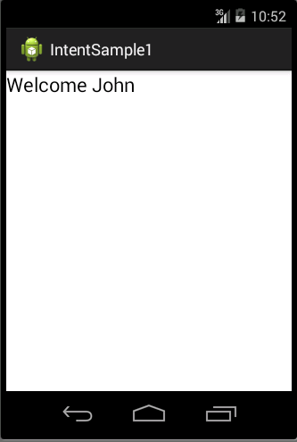

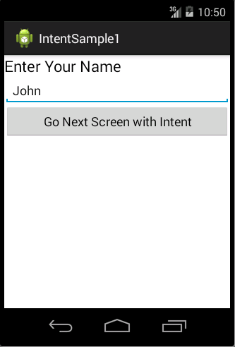

1. Your **activity_main.xml** file should have something similar to xml below: **(p/s: You do not need to follow the xml as it might be different in each design.)**

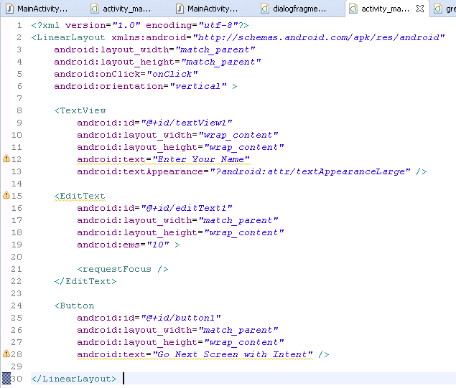

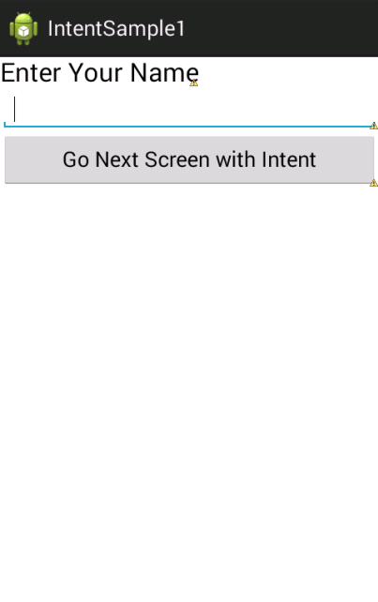

1. Create another file called **greeting.xml in /res/layout.** You should create the interface which similar to the following.

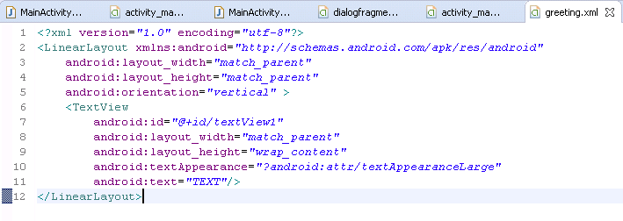

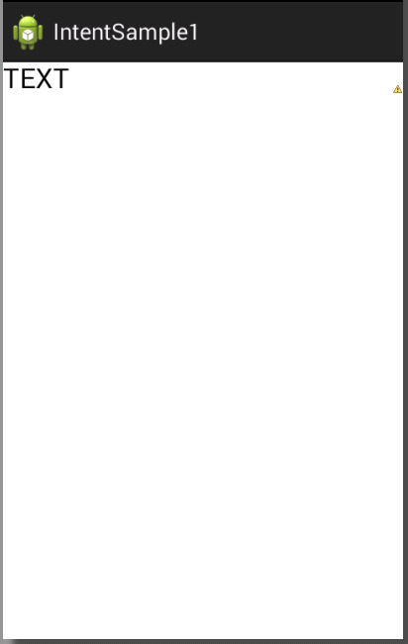

1. In your **IntentExampleActivity.java**, code the following code segment to provide function to the button created in activity_main.xml.

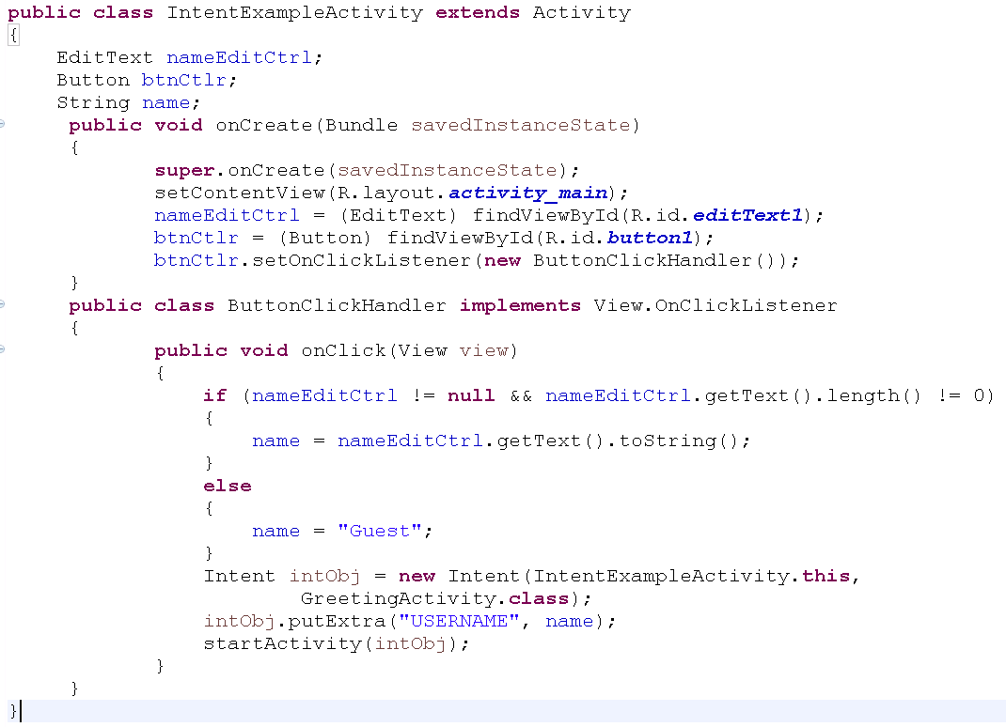

1. Create a class called **GreetingActivity.java**.

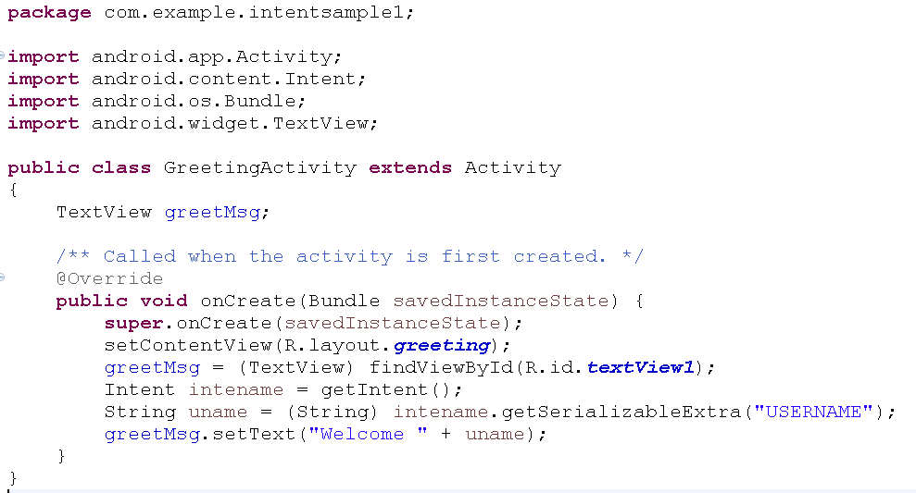

1. Make sure that your AndroidManifest.xml has the following setting:

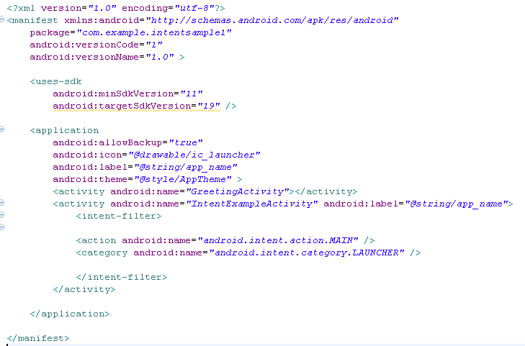

1. After make sure all the coding appropriate done, you may compile and run your coding .

**Question 2 (Implicit Intent)**

1. In this question, you are required to create an app with the following interface.

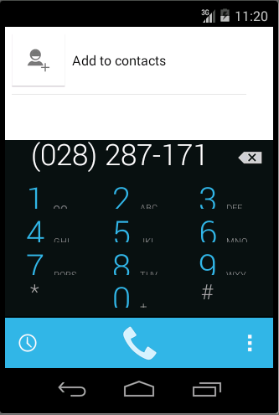

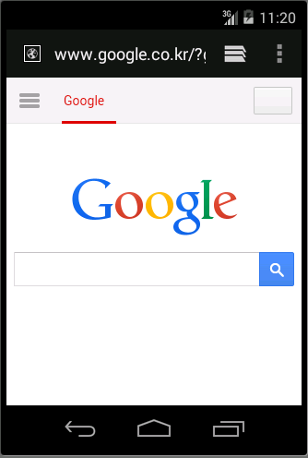

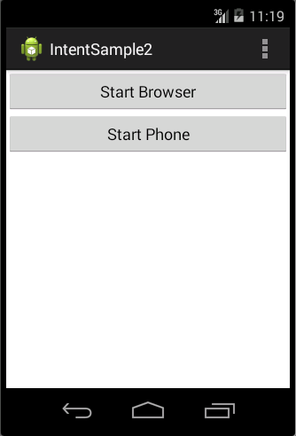

1. Your **activity_main.xml** file should have something similar to xml below: **(p/s: You do not need to follow the xml as it might be different in each design.)**

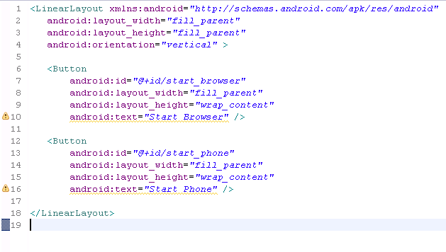



1. In your **MainActivity.java**, code the following code segment to provide function to the button created in activity_main.xml.

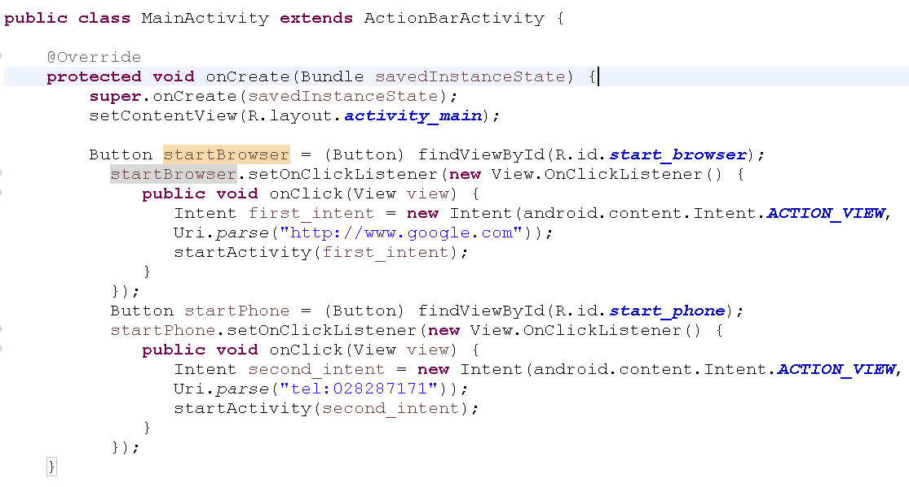

1. Make sure that your AndroidManifest.xml has the following setting:

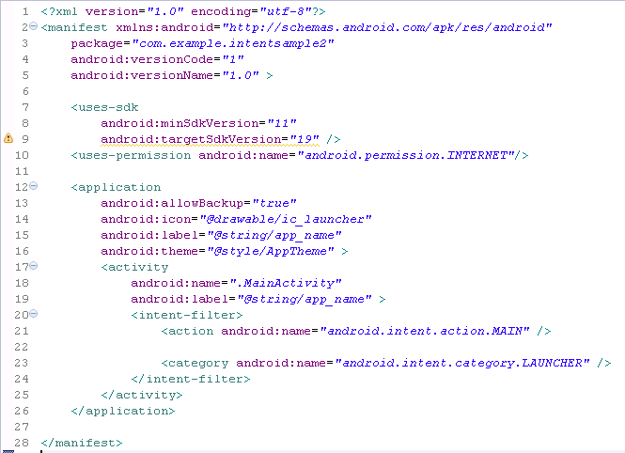

**Question 3(Explicit Intent)**

1. In this question, you are required to create an app with the following interface.

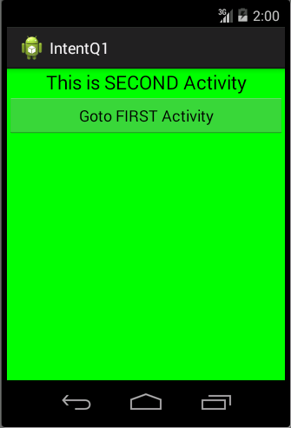

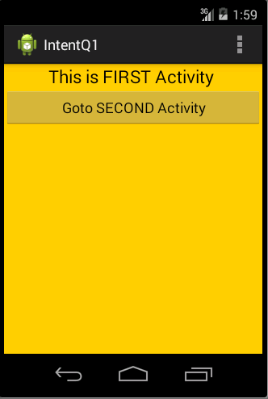

First Activity Second Activity

1. In this question, you should create **TWO** activities. First activity has the background color in yellow and a TextView with labeled “This is FIRST Activity” and also a button with caption “Goto SECOND Activity”. Second activity has the background color in green and a TextView with labeled “This is SECOND Activity” and also a button with caption “Goto FIRST Activity”.
2. When the application start, the First Activity launched. If the user clicks on the button, the second activity shall be launched. When the app in Second Activity, if the user click on the button, the First activity shall then be launched.

**Question 4 (Login App)**

1. In this question, you are required to create an app with the following interface.

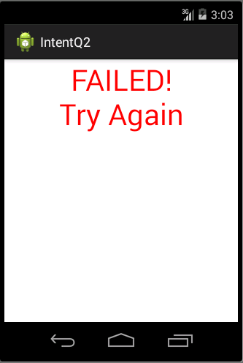

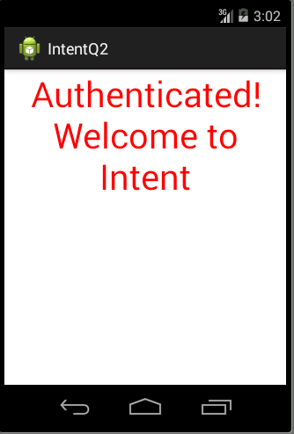

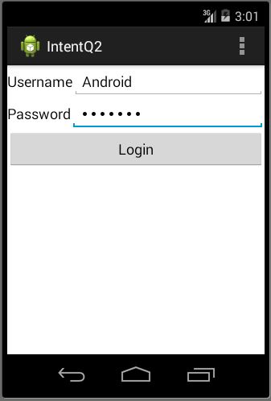

First Activity Second Activity Third Activity

1. In this question, you should create **THREE** activities. First activity should allow user enter the username and password. In this app, we hardcode the username to “Android” and password to “123456”. After the user enter the username and password, user should then click the login button.
2. If the username and password entered correctly, the second activity with message “Authenticated! Welcome to Intent” launched. Else, Third Activity with message “FAILED, Try Again” showed.

**Question 5(Implicit Intent)**

1. In this question, you are required to create an app with the following interface.

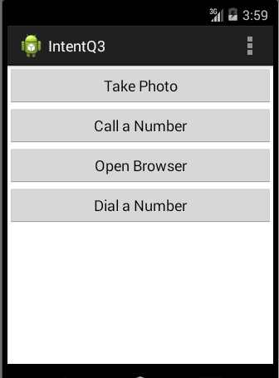

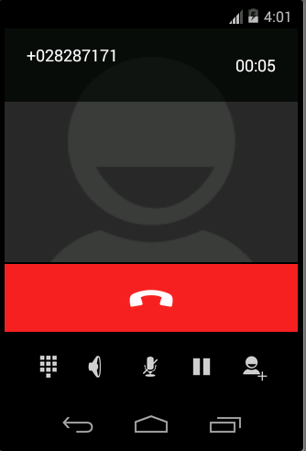

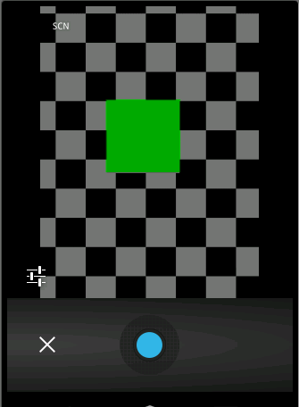

Activity_main.xml Camera Screen Call Number Screen

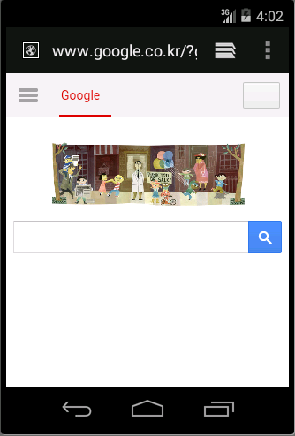

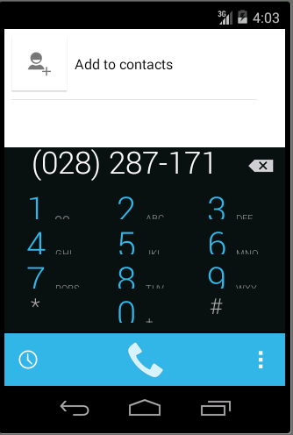

Web Browser Dial Number Screen

1. In this question, you should create **ONE** activity. In this activity, you should include FOUR buttons : Take photo, Call a Number, Open Browser, and also Dial a Number. You should create an Implicit Intent for each of the button. When user click on each of the button, the implicit intent should run and execute the necessary app.